Day2 Activity 5 Worksheet
Use the following patterns. First, describe the distance between the two places. Second, suggest a preferred transportation to get from one place to another.
句型1: Place 1 + 离 + Place 2 + 有＃＃里(路) / Adv. + 近 jìn / 远 yuǎn
句型2: Subject + 还是 + option + 吧
(1)
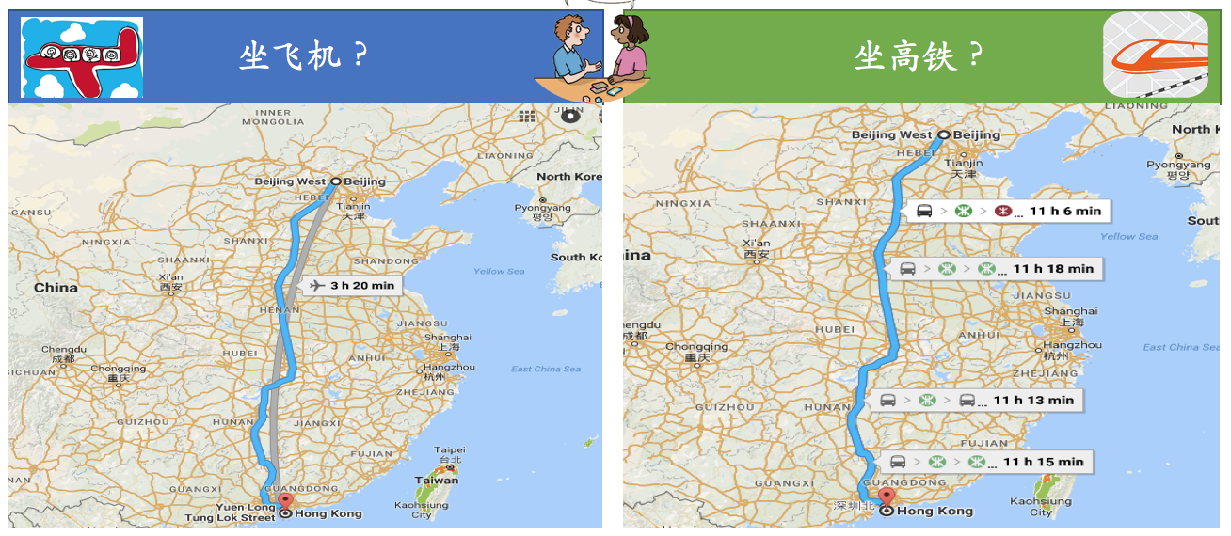

(2)
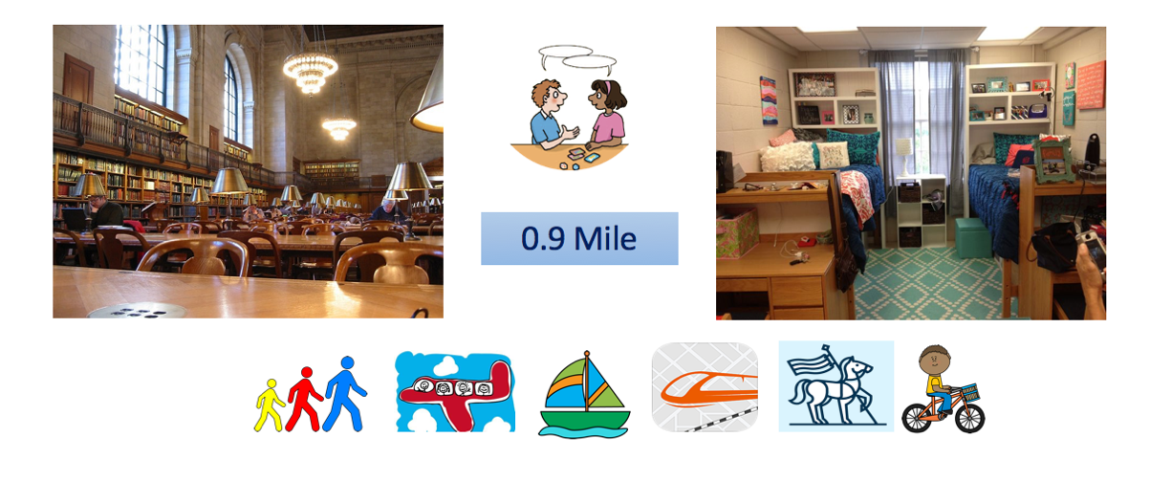
(3)

